Minor Advanced Life Science and Technology:

Registration manual.
Academic year: 2020-21
Programme coordinator: Dr. Helmi R.M. Schlaman (E: Onderwijscoordinator-bachelor-LST@lic.leidenuniv.nl)

Registration as a guest student at TU Delft
Students who are not registered at TU Delft should register at TU Delft as guest student Life Science and Technology. This is obligatory to enrol in classes of the minor A-LST and to make use of Brightspace that requires a TU account, to ensure proper administration of study results, and for insurance reasons.
Procedure:
- By student:
- Log in into Studielink (U: www.studielink.nl)
> Choose Institution of Education: ‘Technische Universiteit Delft’
> Register as ‘Guest student Life Science and Technology (Bachelor level)’
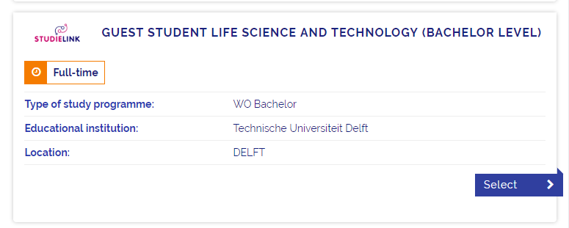
- Present an original (no copy) proof of paid registration fee (‘Bewijs Betaald Collegegeld’) at the Contact Centre, TU Delft.
- Collect your student card (campus card) at the Contact Centre, TU Delft (see point 3 below).
- A proof of admission of the student’s own Board of Examiners is not required (see point 2 below). Please deny the messages if you are asked to submit such a document.
- NOTE: Do Not register as minor student at TU Delft at Studielink.
- By programme coordinator (second half of August the latest):
  - Send list of non-LST students who are admitted to the minor programme A-LST to the student administration of TU Delft via contactcentre-esa@tudelft.nl
- By Student Administration TU Delft:
  - Send student a student number and NetID (TU Delft account) upon registration via Studielink.
  - Registration of student as ‘guest student LST’ under exam type code XB and Bekostiging B but only when proof of paid registration fee (BCC) has been submitted by the student and when admission is registered.
  - Prepare a digital proof of registration that may be downloaded from Osiris.
  - Inform student to collect his student card (campus card) by automatic e-mail before October 2020.

Brightspace is the electronic learning environment of TU Delft. A TU Delft account (NetID) is required to get access to the Brightspace courses.
A proof of paid registration fee can be obtained at the front office of the central student administration of the university where the student is enrolled for his/her major bachelor programme. For Leiden University students, use the ‘contactformulier’ that can be obtained from: http://faq.leidenuniv.nl/questionForm?lang=nl
Student Administration, team Enrolment & Finance, Jaffalaan 9a, 2628 BX Delft. E: contactcentre-esa@tudelft.nl T: 015-278 8012
By law, is it not permitted to send campus cards to your personal address. You should pick it up yourself at the address indicated at footnote 3 above.

